Spring Data JPA Supplier Coffee 已知表格1對多
這隻程式是針對已經建置完成Suppliers Coffees 1對多新增及查詢
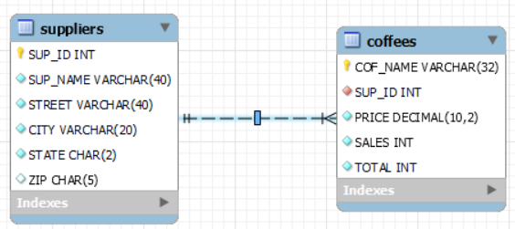
application.properties

spring.datasource.url=jdbc:mysql://localhost:3306/classicmodels
spring.datasource.username=root
spring.datasource.password=1234
spring.datasource.driver-class-name=com.mysql.cj.jdbc.Driver

spring.jpa.show-sql = true
spring.jpa.properties.hibernate.format_sql=true
spring.jpa.properties.hibernate.dialect = org.hibernate.dialect.MySQL8Dialect

# create-drop update validate
spring.jpa.properties.hibernate.hbm2ddl.auto=validate

#logging.level.org.hibernate.SQL=DEBUG
#logging.level.org.hibernate.type.descriptor.sql.BasicBinder=TRACE

#spring.jpa.hibernate.naming.implicit-strategy=org.hibernate.boot.model.naming.ImplicitNamingStrategyLegacyJpaImpl
#spring.jpa.hibernate.naming.physical-strategy=org.hibernate.boot.model.naming.PhysicalNamingStrategyStandardImpl
Supplier.java

package com.coffee.supplier.model;
import java.util.List;
import javax.persistence.CascadeType;
import javax.persistence.Column;
import javax.persistence.Entity;
import javax.persistence.Id;
import javax.persistence.OneToMany;
import javax.persistence.Table;
import com.fasterxml.jackson.annotation.JsonManagedReference;

@Entity
@Table(name="suppliers")
public class Supplier implements java.io.Serializable{

@Id
@Column(name="SUP_ID")
private Integer supId;

@Column(name="SUP_Name")
private String supName;
private String street;
private String city;
@Column(name="state", columnDefinition="CHAR(2)")
private String state;
@Column(name="zip", columnDefinition="CHAR(5)")
private String zip;

@JsonManagedReference // 為防止遞迴循環讀取資料
@OneToMany(mappedBy = "supplier", cascade=CascadeType.ALL)
private List<Coffee> coffees;

public Supplier() {}
public Supplier(Integer supId, String supName, String street, String city, String state, String zip ) {

this.supId = supId;
this.supName = supName;
this.street = street;
this.city = city;
this.state = state;
this.zip = zip;
}

public Integer getSupId() {
return supId;
}

public void setSupId(Integer supID) {
this.supId = supID;
}

public String getSupName() {
return supName;
}

public void setSupName(String supName) {
this.supName = supName;
}

public String getStreet() {
return street;
}

public void setStreet(String street) {
this.street = street;
}

public String getCity() {
return city;
}

public void setCity(String city) {
this.city = city;
}

public String getState() {
return state;
}

public void setState(String state) {
this.state = state;
}

public String getZip() {
return zip;
}

public void setZip(String zip) {
this.zip = zip;
}

public List<Coffee> getCoffees() {
return coffees;
}

public void setCoffees(List<Coffee> coffees) {
this.coffees = coffees;
}
// toString() 沒有包含多的 Coffees
@Override
public String toString() {
return "Supplier [supId=" + supId + ", supName=" + supName + ", street=" + street + ", city=" + city + ", state=" + state + ", zip=" + zip + "]";
}
}

Coffee.java

import javax.persistence.Column;
import javax.persistence.Entity;
import javax.persistence.Id;
import javax.persistence.JoinColumn;
import javax.persistence.ManyToOne;
import javax.persistence.Table;

import com.fasterxml.jackson.annotation.JsonBackReference;
import com.fasterxml.jackson.annotation.JsonIgnoreProperties;

@Entity
@Table(name="coffees")
public class Coffee implements java.io.Serializable{

@Id
@Column(name="COF_Name")
private String cofName;
@Column(name="price", columnDefinition="Decimal(10,2)")
private double price;
private int sales;
private int total;

@JsonIgnoreProperties("coffees")
@JsonBackReference //跟 Supplier @JsonManagedReference 對應設定
@ManyToOne
@JoinColumn(name="SUP_ID", nullable=false)
private Supplier supplier;

public Coffee() {}

public Coffee(String cofName, double price, int sales, int total) {

this.cofName = cofName;
this.price = price;
this.sales = sales;
this.total = total;

}
public String getCofName() {
return cofName;
}
public void setCofName(String cofName) {
this.cofName = cofName;
}
public double getPrice() {
return price;
}
public void setPrice(double price) {
this.price = price;
}
public int getSales() {
return sales;
}
public void setSales(int sales) {
this.sales = sales;
}
public int getTotal() {
return total;
}
public void setTotal(int total) {
this.total = total;
}
public Supplier getSupplier() {
return supplier;
}
public void setSupplier(Supplier supplier) {
this.supplier = supplier;
}
@Override
public String toString() {
return "Coffee [cofName=" + cofName + ", price=" + price + ", sales=" + sales + ", total=" + total + ", supplier=" + supplier + "]";
}
}
Repository 設定:
import org.springframework.data.jpa.repository.JpaRepository;
public interface SupplierRepository extends JpaRepository<Supplier, Integer>{
public Supplier findBySupId(Integer id);

}

import java.util.List;

import org.springframework.data.jpa.repository.JpaRepository;
public interface CoffeeRepository extends JpaRepository<Coffee, String>{
public List<Coffee> findBySupplier(Supplier sup);
public Coffee findByCofName(String name);
}

Controller:

import java.util.ArrayList;
import java.util.List;
import org.springframework.beans.factory.annotation.Autowired;
import org.springframework.stereotype.Controller;
import org.springframework.transaction.annotation.Propagation;
import org.springframework.transaction.annotation.Transactional;
import org.springframework.ui.Model;
import org.springframework.web.bind.annotation.GetMapping;
import org.springframework.web.bind.annotation.PathVariable;
import org.springframework.web.bind.annotation.PostMapping;
import org.springframework.web.bind.annotation.RequestBody;
import org.springframework.web.bind.annotation.RequestMapping;
import org.springframework.web.bind.annotation.ResponseBody;

@Controller
@RequestMapping("/coffees")
public class CoffeeController {

@Autowired
public CoffeeRepository cofRepository;

@GetMapping
public @ResponseBody List<Coffee> listCoffee(){

List<Coffee> cofTest = cofRepository.findAll();
return cofTest;
}

@GetMapping(value="/coffeesupplier/{cofName}")
public @ResponseBody Supplier getsupplier(@PathVariable("cofName")String cofName){
List<Coffee> cofs= cofRepository.findAll();
Coffee cof = cofs.stream().filter(c->c.getCofName().equals(cofName)).findFirst().get();
return cof.getSupplier();
}

@PostMapping(value="/saveCoffee")
@Transactional(propagation = Propagation.REQUIRED)
public String saveCoffee(@RequestBody Coffee cof) {

cofRepository.save(cof);
return "redirect:/coffees/coffeeRetrieveAll";

}

@GetMapping("/coffeeRetrieveAll")
public @ResponseBody List<Coffee> cofList(Model model){

List<Coffee> cofList = cofRepository.findAll();
return cofList;
}

@GetMapping("/updateCoffee")
public String updateCoffee(@PathVariable("name")String CofName, Model model) {

List<Supplier> sup = new ArrayList<>();
model.addAttribute("supList", sup);

Coffee coffee = cofRepository.findByCofName(CofName);
model.addAttribute("cofUpdate", coffee);
return "updateCoffee"; // return thymleaf UI
}

@PostMapping("/updateCoffee")
@Transactional(propagation = Propagation.REQUIRED)
public String updateCoffee(@RequestBody Coffee cof) {

cofRepository.save(cof);
System.out.println("update:"+cof);
return "redirect:/coffees/coffeeRetrieveAll";
}

@GetMapping("/deleteCoffee")
@Transactional(propagation = Propagation.REQUIRED)
public String deleteCoffee(@PathVariable("name")String CofName) {

Coffee coffee = cofRepository.findByCofName(CofName);
System.out.println("delete:"+coffee);
if(coffee !=null)
cofRepository.delete(coffee);
return "redirect:/coffees/coffeeRetrieveAll";
}
}

SupplierController:

import java.util.List;
import org.springframework.beans.factory.annotation.Autowired;
import org.springframework.stereotype.Controller;
import org.springframework.transaction.annotation.Propagation;
import org.springframework.transaction.annotation.Transactional;
import org.springframework.ui.Model;
import org.springframework.web.bind.annotation.GetMapping;
import org.springframework.web.bind.annotation.PathVariable;
import org.springframework.web.bind.annotation.PostMapping;
import org.springframework.web.bind.annotation.RequestBody;
import org.springframework.web.bind.annotation.RequestMapping;
import org.springframework.web.bind.annotation.RequestMethod;
import org.springframework.web.bind.annotation.ResponseBody;

import com.coffee.supplier.model.*;
import com.coffee.supplier.service.*;

@Controller
@RequestMapping("/suppliers")
public class SupplierController {

@Autowired
public SupplierRepository supRepository;

@PostMapping("/saveSupplier")
@Transactional(propagation = Propagation.REQUIRED)
public String saveSupplier(@RequestBody Supplier sup) {
supRepository.save(sup);
System.out.println("save:"+sup);
return "redirect:/suppliers/supplierRetrieveAll";
}

@RequestMapping(value={"/supplierRetrieveAll",""},method=RequestMethod.GET)
public @ResponseBody List<Supplier> supList(){

return supRepository.findAll();

}

@GetMapping("/updateSupplier")
public String updateSupplier(@PathVariable("id")Integer id, Model model) {

Supplier sup = supRepository.findBySupId(id);
model.addAttribute("supUpdate", sup);

return "updateSupplier"; // return thymeleaf UI
}

@PostMapping("/updateSupplier")
@Transactional(propagation = Propagation.REQUIRED)
public String updateSupplier(@RequestBody Supplier sup) {

supRepository.save(sup);
System.out.println("update:"+sup);
return "redirect:/suppliers/supplierRetrieveAll";
}

@GetMapping(value="/find/{name}")
public @ResponseBody List<Coffee> find(@PathVariable("name")String supName){
List<Supplier> data=supRepository.findAll();
Supplier sp=data.stream().filter(s->s.getSupName().equals(supName)).findFirst().get();
return sp.getCoffees();
}

}
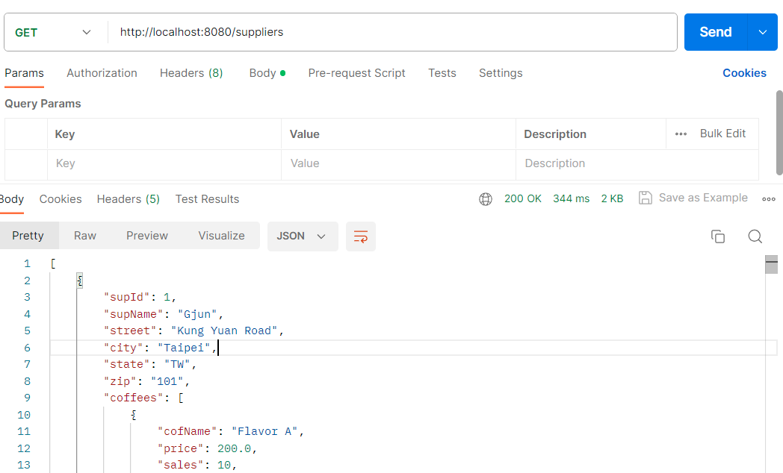
詳細資料:
[
{
"supId": 1,
"supName": "Gjun",
"street": "Kung Yuan Road",
"city": "Taipei",
"state": "TW",
"zip": "101",
"coffees": [
{
"cofName": "Flavor A",
"price": 200.0,
"sales": 10,
"total": 5
},
{
"cofName": "Flavor B",
"price": 100.0,
"sales": 11,
"total": 6
}
]
},
{
"supId": 2,
"supName": "Bigs Coffee Inc.,",
"street": "Kung Yuan 30",
"city": "Taipei",
"state": "TW",
"zip": "100",
"coffees": [
{
"cofName": "Bigs Gold Brand",
"price": 250.0,
"sales": 300,
"total": 99
}
]
},
{
"supId": 3,
"supName": "Gjun 3",
"street": "Kung Yuan Road",
"city": "Taipei",
"state": "TW",
"zip": "100",
"coffees": [
{
"cofName": "Gjun Flavor A",
"price": 100.0,
"sales": 10,
"total": 10
}
]
},
{
"supId": 10,
"supName": "TestSupllier",
"street": "Kung yuan Road",
"city": "Taipei",
"state": "NA",
"zip": "100",
"coffees": []
},
{
"supId": 11,
"supName": "Supllier2",
"street": "Kung yuan Road 2",
"city": "Taipei",
"state": "NA",
"zip": "100",
"coffees": []
},
{
"supId": 20,
"supName": "Gjun",
"street": "Kung Yuan Road 30",
"city": "Taipei",
"state": "TW",
"zip": "101",
"coffees": []
},
{
"supId": 49,
"supName": "Superior Coffee",
"street": "1 Party Place",
"city": "Mendocino",
"state": "CA",
"zip": "95460",
"coffees": [
{
"cofName": "French_Roast",
"price": 8.99,
"sales": 0,
"total": 0
},
{
"cofName": "French_Roast_Decaf",
"price": 9.99,
"sales": 0,
"total": 0
}
]
},
{
"supId": 101,
"supName": "Acme, Inc.",
"street": "99 Market Street",
"city": "Groundsville",
"state": "CA",
"zip": "95199",
"coffees": [
{
"cofName": "Colombian",
"price": 7.99,
"sales": 0,
"total": 0
},
{
"cofName": "Colombian_Decaf",
"price": 8.99,
"sales": 0,
"total": 0
}
]
},
{
"supId": 150,
"supName": "The High Ground",
"street": "100 Coffee Lane",
"city": "Meadows",
"state": "CA",
"zip": "93966",
"coffees": [
{
"cofName": "Espresso",
"price": 9.99,
"sales": 0,
"total": 0
}
]
},
{
"supId": 456,
"supName": "Restaurant Supplies, Inc.",
"street": "200 Magnolia Street",
"city": "Meadows",
"state": "CA",
"zip": "93966",
"coffees": []
},
{
"supId": 927,
"supName": "Professional Kitchen",
"street": "300 Daisy Avenue",
"city": "Groundsville",
"state": "CA",
"zip": "95199",
"coffees": []
}
]
1對多資料儲存
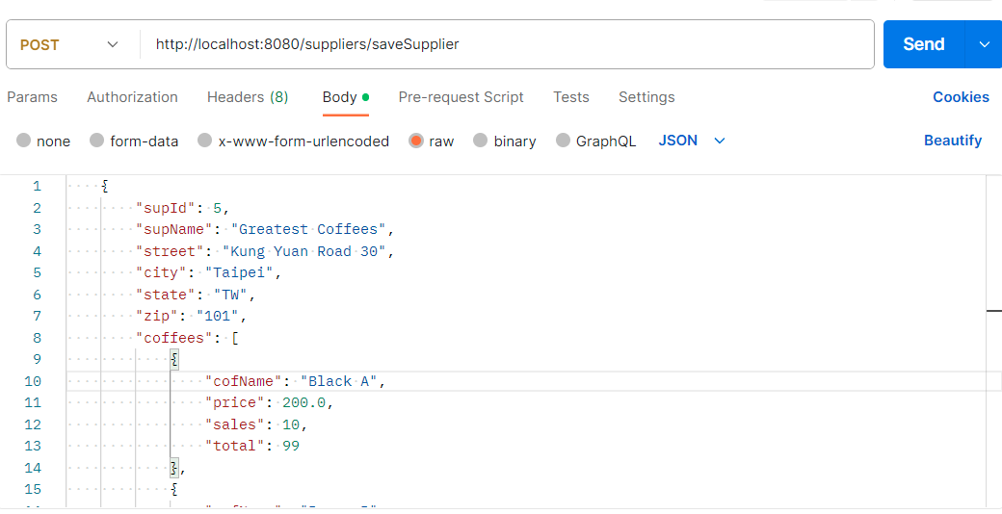

http://localhost:8080/suppliers/saveSupplier
{
"supId": 5,
"supName": "Greatest Coffees",
"street": "Kung Yuan Road 30",
"city": "Taipei",
"state": "TW",
"zip": "101",
"coffees": [
{
"cofName": "Black A",
"price": 200.0,
"sales": 10,
"total": 99
},
{
"cofName": "Brown B",
"price": 100.0,
"sales": 11,
"total": 19
}
]
}

